Alec Waldron

A01859971

The White Owl Project Report

The main purpose of my App is spreading information to the customers of The White Owl. Specifically, directions to The White Owl from your current location, our food menu, beers currently on tap, our daily specials, and any announcement the owner would like to send. Below are screenshots of the directions activity and daily specials activity.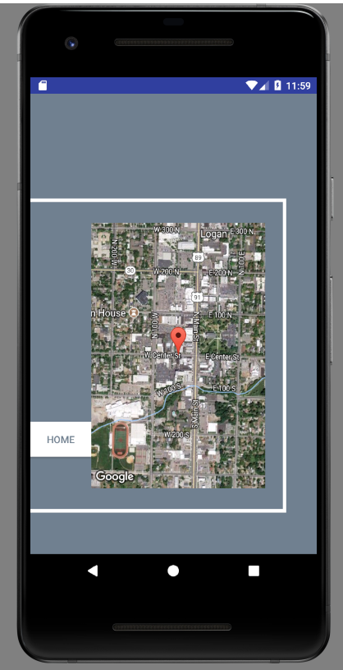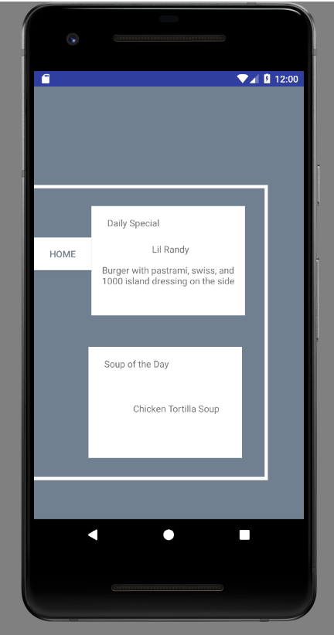

One of the biggest challenges I faced was getting the map fragments for directions to work. After hours of trying to figure it out, I realized I had it declared as a MapFragment in the .xml file and was calling it was a SupportMapFragment in the java file. Another issue I had was creating a custom adapter for the listview I used to display the menu. Luckily, the in class demo we did helped me with this a lot. The main issue I didn’t resolve was creating a website for the owner to update info in real time. All updates must be done manually in the .txt files in the project directory.

The first improvement to be made is creating the website. After that all improvements are related to design. Using the company logo in the main activity for starters. Using pictures in the food menu and beers on tap activity. Formatting the food menu into categories. The app needs a lot of polishing before I have a finished product.